Homework 3 – Integrate and calculate the error of the following integral:
$$\int_{-1}^{1}{\left[4x^{3}+3x+1\right]dx}$$

Evaluating the integral with just calculus, the result is shown:
$${\left.{\int_{-1}^{1}{\left[4x^{3}+3x+1\right]dx}=x}^{4}+\frac{3}{2}x^{2}+x\right|}_{-1}^{1}=\left[{\left(1\right)}^{4}+\frac{3}{2}{\left(1\right)}^{2}+\left(1\right)\right]-\left[{\left(-1\right)}^{4}+\frac{3}{2}{\left(-1\right)}^{2}+\left(-1\right)\right]=2$$
The error for this method is none since it is the integral value.

Evaluating the integral via the trapezoidal method with intervals of .05:
$$\int_{-1}^{1}{f\left(x\right)dx}≈$$
$$\left[\frac{1}{2}f\left(-1.00\right)+f\left(-0.95\right)+f\left(-0.90\right)+…+f\left(0.00\right)+…+f\left(0.90\right)+f\left(0.95\right)+\frac{1}{2}f\left(1.00\right)\right]$$
$$=\left[\frac{1}{2}*\left(-6.00\right)+\left(-5.28\right)+\left(-4.62\right)+…+\left(1\right)+…+\left(6.62\right)+\left(7.28\right)+\frac{1}{2}\left(8.00\right)\right]$$
Using the following program:
#include <iostream>
#include <cmath>
#include <iomanip>

using namespace std;

int main()
{
long double i = -1, f = 1, f_x = 0, dx = .05, Sum = 0, Integral = 0;
long double f_i = 4 * pow(-1, 3) + 3 * (-1) + 1;

while (i < (f - dx))
{
i = i + dx;
f_x = 4 * pow(i, 3) + 3 * i + 1;
Sum = Sum + f_x;
};

long double f_f = 4 * pow(1, 3) + 3 * (1) + 1;
Integral = (.5*f_i + Sum + .5*f_f)*dx;
cout << Integral << endl;

return 0;
}

The result is that no matter what dx is chosen, the integral value will always be 2, as long as the dx can properly divide the interval.

Evaluating the integral via Simpson’s Rule:
$$\int_{-1}^{1}{f\left(x\right)dx≈\frac{f\left(1\right)}{3}+\frac{4f\left(0\right)}{3}+\frac{f\left(-1\right)}{3}=\frac{\left[8.00\right]}{3}+\frac{4*\left[1\right]}{3}+\frac{\left[-6.00\right]}{3}=2}$$
The Simpson’s Rule seems to give the same answer like the other two methods.

Final Comments:
Because of the nature of the integral in the interval it is in:
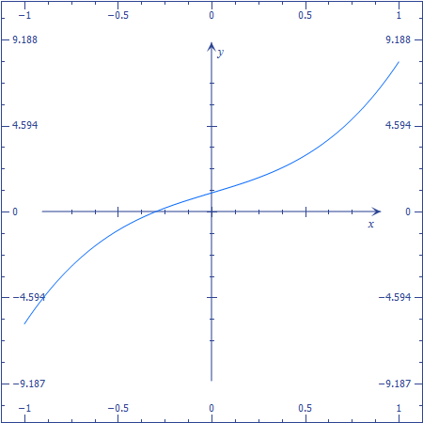
It is almost linear and that is why all the integration methods have been showing to be this accurate. The error is 0 only because of this almost linear behavior.

